Robust clipped correlation: EURUSD and EURGBP
Method 04 / daily log returns clipped at ±0.01, ±0.02, ±0.03 / Alpari D1 full available history

Study setup
Logical pair: EURUSD , EURGBP
Broker symbols: EURUSD_i , EURGBP_i
Snapshot: 2026-11-03_majors_alpari_D1
Timeframe: D1
Matched return window: 1999-01-06 to 2026-11-02 (UTC bar dates)
Matched return count n: 7183
Dropped unfinished last bar dated 2026-11-03 UTC after a tick-volume check against the prior complete day.
Clip bounds c in log-return units: 0.01, 0.02, 0.03 (about ±1%, ±2%, ±3% on the log scale). Headline c = 0.02.
Clipping caps a day's magnitude at ±c and keeps the row; it does not drop the day, so n is the same at every c.
Complete matched rows (Excel): EURUSD-EURGBP_Clipped_D1.xlsx
Complete matched rows (HTML table): EURUSD-EURGBP_Clipped_D1_data.html

Method carried forward
Each matched daily log return of close, ln(close_t / close_t-1), is clipped in the broker quote direction before Pearson correlation: x_tilde = min(c, max(-c, x)) and y_tilde = min(c, max(-c, y)), then rho_clip = Pearson(x_tilde, y_tilde) on the same rows as raw Pearson r. Quotes are not inverted. A day beyond ±c stays in the sample at the cap; n does not change. rho_clip is symmetric under swap of the two symbols. rho_clip = 0 means no straight-line link among the clipped values in this sample; it does not mean no link of any kind. The score is not a cause, not a lead, and not a trading signal. Daily rows are not independent draws, so the two-sided p-value and Fisher interval are reported and treated as secondary to rho_clip. Cap-hit counts (|log return| > c) flag how much of each leg was capped.

Raw Pearson on the same rows
Pearson r: 0.439899
Two-sided p-value: 0
Approximate 95% Fisher interval: [0.421056, 0.458362]
This is the unclipped comparison required by the method. The headline score is rho_clip at c = 0.02 below.

Clipped results
n = 7183 at every c. Headline row is c = 0.02. Cap-hit count is the number of days with |log return| > c before clipping.
c | rho_clip | p | ci_low | ci_high | rho_minus_r | EURUSD_cap_hits | EURGBP_cap_hits | EURUSD_cap_share | EURGBP_cap_share
0.01 | 0.447399 | 0 | 0.42870815 | 0.46570672 | 0.0075001797 | 619 | 344 | 0.086176 | 0.047891
0.02 | 0.453903 | 0 | 0.4353464 | 0.47207392 | 0.014004268 | 41 | 18 | 0.005708 | 0.002506
0.03 | 0.44759 | 0 | 0.4289031 | 0.46589376 | 0.0076912197 | 4 | 3 | 0.000557 | 0.000418

Conclusion
Over 7183 matched daily log-return rows for EURUSD and EURGBP (broker quote directions unchanged), headline robust clipped correlation at c=0.02 is 0.4539 (positive, moderate straight-line association among clipped values in this sample). Approximate 95% Fisher interval on the clipped series: [0.4353, 0.4721]. Same-sample raw Pearson r is 0.4399 (rho_clip minus r = 0.0140). Sensitivity across the fixed grid: c=0.01 same sign; c=0.02 same sign; c=0.03 same sign. Two-sided p under the usual independent bivariate-normal model is 0; that model does not match linked daily FX returns, so treat p as secondary. This does not establish cause, lead-lag, or a lasting trading rule.

What to look at in this file next time
1) rho_clip at c = 0.02 versus raw Pearson r. 2) Whether c = 0.01 and c = 0.03 keep the same sign as 0.02. 3) Cap-hit counts before treating a large gap as settled. 4) The ±0.02 lines on the returns chart and the clip box on the scatter.

Charts
Daily closes

Daily log returns with +/- 0.02 clip lines
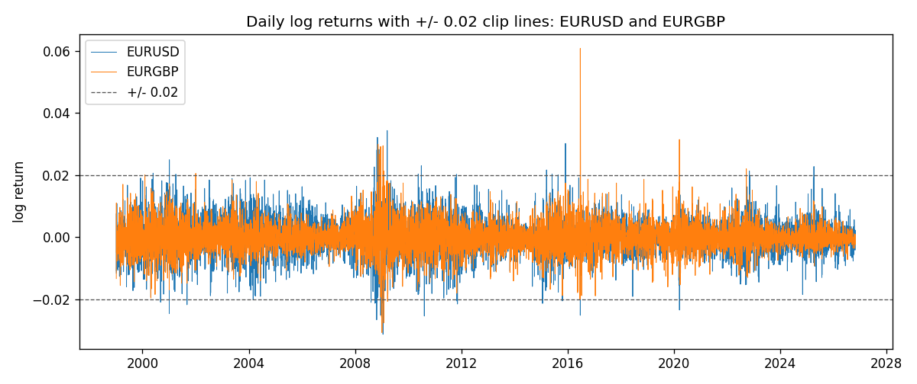
Log-return scatter with +/- 0.02 clip box
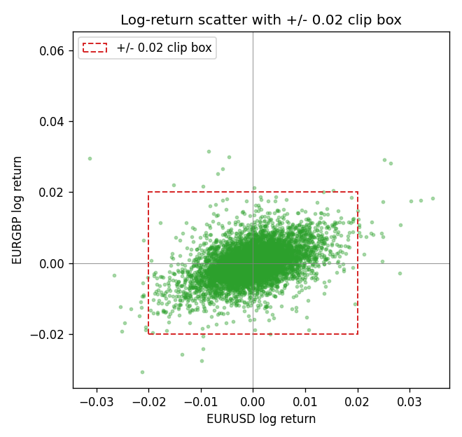

Data report
Every matched row that entered the clipped and raw correlations is stored in the sibling Excel workbook named EURUSD-EURGBP_Clipped_D1.xlsx. That file is the complete data archive for redrawing charts. Embedding all rows as a Word table is impractical at this length; the Word file holds the column list, column summaries, and the first and last 15 matched rows.
Columns: time, EURUSD_open, EURGBP_open, EURUSD_high, EURGBP_high, EURUSD_low, EURGBP_low, EURUSD_close, EURGBP_close, EURUSD_tick_volume, EURGBP_tick_volume, EURUSD_spread, EURGBP_spread, EURUSD_real_volume, EURGBP_real_volume, EURUSD_log_return, EURGBP_log_return, EURUSD_log_return_clip_0p01, EURGBP_log_return_clip_0p01, EURUSD_log_return_clip_0p02, EURGBP_log_return_clip_0p02, EURUSD_log_return_clip_0p03, EURGBP_log_return_clip_0p03
Column summaries (matched calculation rows)
column | count | mean | std | min | 25% | 50% | 75% | max
EURUSD_open | 7183 | 1.1815763 | 0.15079461 | 0.8272 | 1.08621 | 1.16623 | 1.29409 | 1.5995
EURGBP_open | 7183 | 0.78698868 | 0.09663692 | 0.5734 | 0.6877 | 0.83389 | 0.86522 | 0.9769
EURUSD_high | 7183 | 1.1867072 | 0.15139096 | 0.8326 | 1.09029 | 1.17134 | 1.29941 | 1.6038
EURGBP_high | 7183 | 0.79006638 | 0.09701205 | 0.5789 | 0.6897 | 0.8369 | 0.8681 | 0.9799
EURUSD_low | 7183 | 1.1765677 | 0.15011491 | 0.8227 | 1.08209 | 1.16259 | 1.288515 | 1.5865
EURGBP_low | 7183 | 0.78428899 | 0.09645396 | 0.5682 | 0.6857 | 0.83166 | 0.86287 | 0.9661
EURUSD_close | 7183 | 1.1816163 | 0.15076829 | 0.8267 | 1.086135 | 1.16619 | 1.2941 | 1.5997
EURGBP_close | 7183 | 0.78703222 | 0.09663758 | 0.5735 | 0.6878 | 0.83395 | 0.86536 | 0.977
EURUSD_tick_volume | 7183 | 103246.15 | 173560.03 | 218 | 9420.5 | 52790 | 99596.5 | 1471626
EURGBP_tick_volume | 7183 | 87133.93 | 145499.42 | 154 | 6594.5 | 44358 | 81413 | 1424684
EURUSD_spread | 7183 | 19.326744 | 16.542159 | 0 | 8 | 12 | 20 | 50
EURGBP_spread | 7183 | 21.324655 | 19.119277 | 0 | 4 | 13 | 40 | 50
EURUSD_real_volume | 7183 | 4.0347326e+10 | 1.669497e+11 | 0 | 0 | 0 | 0 | 3.6149665e+12
EURGBP_real_volume | 7183 | 2.7872287e+10 | 1.3521454e+11 | 0 | 0 | 0 | 0 | 3.5726265e+12
EURUSD_log_return | 7183 | -5.81e-06 | 0.0057996 | -0.03123819 | -0.00324487 | 0 | 0.00325442 | 0.03433183
EURGBP_log_return | 7183 | 2.227e-05 | 0.00487305 | -0.03067367 | -0.00262314 | -9.879e-05 | 0.00256076 | 0.06075387
EURUSD_log_return_clip_0p01 | 7183 | -8.7e-06 | 0.00500895 | -0.01 | -0.00324487 | 0 | 0.00325442 | 0.01
EURGBP_log_return_clip_0p01 | 7183 | -4.4e-07 | 0.00435251 | -0.01 | -0.00262314 | -9.879e-05 | 0.00256076 | 0.01
EURUSD_log_return_clip_0p02 | 7183 | -1.186e-05 | 0.00571385 | -0.02 | -0.00324487 | 0 | 0.00325442 | 0.02
EURGBP_log_return_clip_0p02 | 7183 | 1.146e-05 | 0.0047598 | -0.02 | -0.00262314 | -9.879e-05 | 0.00256076 | 0.02
EURUSD_log_return_clip_0p03 | 7183 | -6.57e-06 | 0.00579361 | -0.03 | -0.00324487 | 0 | 0.00325442 | 0.03
EURGBP_log_return_clip_0p03 | 7183 | 1.788e-05 | 0.00483115 | -0.03 | -0.00262314 | -9.879e-05 | 0.00256076 | 0.03
First 15 matched rows (selected columns)
time | EURUSD_close | EURGBP_close | EURUSD_log_return | EURGBP_log_return | EURUSD_log_return_clip_0p02 | EURGBP_log_return_clip_0p02
1999-01-06 | 1.1623 | 0.7019 | -0.011547966 | -0.013303338 | -0.011547966 | -0.013303338
1999-01-07 | 1.1712 | 0.7097 | 0.0076280636 | 0.011051402 | 0.0076280636 | 0.011051402
1999-01-08 | 1.1585 | 0.7062 | -0.010902799 | -0.004943862 | -0.010902799 | -0.004943862
1999-01-11 | 1.1503 | 0.7053 | -0.007103287 | -0.0012752393 | -0.007103287 | -0.0012752393
1999-01-12 | 1.1555 | 0.7077 | 0.0045103728 | 0.0033970309 | 0.0045103728 | 0.0033970309
1999-01-13 | 1.1681 | 0.708 | 0.010845346 | 0.00042381861 | 0.010845346 | 0.00042381861
1999-01-14 | 1.1681 | 0.7066 | 0 | -0.0019793588 | 0 | -0.0019793588
1999-01-15 | 1.1563 | 0.7012 | -0.010153245 | -0.0076715819 | -0.010153245 | -0.0076715819
1999-01-18 | 1.1605 | 0.7017 | 0.0036256946 | 0.00071280921 | 0.0036256946 | 0.00071280921
1999-01-19 | 1.1603 | 0.7007 | -0.00017235436 | -0.0014261269 | -0.00017235436 | -0.0014261269
1999-01-20 | 1.1566 | 0.7021 | -0.0031939256 | 0.0019960086 | -0.0031939256 | 0.0019960086
1999-01-21 | 1.1601 | 0.7016 | 0.0030215416 | -0.00071240297 | 0.0030215416 | -0.00071240297
1999-01-22 | 1.1587 | 0.7004 | -0.0012075213 | -0.0017118406 | -0.0012075213 | -0.0017118406
1999-01-25 | 1.1552 | 0.6966 | -0.0030251979 | -0.0054402425 | -0.0030251979 | -0.0054402425
1999-01-26 | 1.1562 | 0.6962 | 0.00086527651 | -0.00057438255 | 0.00086527651 | -0.00057438255
Last 15 matched rows (selected columns)
time | EURUSD_close | EURGBP_close | EURUSD_log_return | EURGBP_log_return | EURUSD_log_return_clip_0p02 | EURGBP_log_return_clip_0p02
2026-10-13 | 1.11965 | 0.84458 | 0.0037402957 | 0.00020130374 | 0.0037402957 | 0.00020130374
2026-10-14 | 1.11545 | 0.84553 | -0.0037582255 | 0.0011241873 | -0.0037582255 | 0.0011241873
2026-10-15 | 1.12172 | 0.84479 | 0.0056053107 | -0.00087557391 | 0.0056053107 | -0.00087557391
2026-10-16 | 1.12371 | 0.84307 | 0.0017724895 | -0.0020380844 | 0.0017724895 | -0.0020380844
2026-10-19 | 1.12086 | 0.84259 | -0.0025394633 | -0.00056950988 | -0.0025394633 | -0.00056950988
2026-10-20 | 1.12354 | 0.83957 | 0.0023881672 | -0.0035906254 | 0.0023881672 | -0.0035906254
2026-10-21 | 1.12318 | 0.83839 | -0.00032046717 | -0.00140647 | -0.00032046717 | -0.00140647
2026-10-22 | 1.12139 | 0.83682 | -0.0015949606 | -0.0018743924 | -0.0015949606 | -0.0018743924
2026-10-23 | 1.11989 | 0.83751 | -0.001338521 | 0.00082421033 | -0.001338521 | 0.00082421033
2026-10-26 | 1.11735 | 0.83762 | -0.0022706559 | 0.00013133309 | -0.0022706559 | 0.00013133309
2026-10-27 | 1.11272 | 0.83595 | -0.004152342 | -0.0019957343 | -0.004152342 | -0.0019957343
2026-10-28 | 1.1152 | 0.83651 | 0.0022262927 | 0.00066967224 | 0.0022262927 | 0.00066967224
2026-10-29 | 1.11772 | 0.83553 | 0.0022571351 | -0.0011722209 | 0.0022571351 | -0.0011722209
2026-10-30 | 1.11644 | 0.83351 | -0.0011458446 | -0.0024205543 | -0.0011458446 | -0.0024205543
2026-11-02 | 1.11881 | 0.83426 | 0.002120569 | 0.00089940465 | 0.002120569 | 0.00089940465

